FATHER, CAN WE DO THE SAME THING IN MASS FOR A FEW WEEKS IN A ROW?
Sunday, January 30, 2022 at 06:24PM
https://www.orderoftheascension.org/means-of-grace-hope-of-glory/2022/1/30/father-can-we-do-the-same-thing-in-mass-for-a-few-weeks-in-a.html

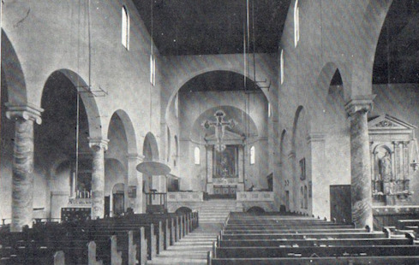

I was the new vicar. At coffee hour that first Sunday I invited people to ask me questions. The first one was from Rose, “Father, can we do the same thing in mass for a few weeks in a row?” I came to understand that they had gone through years of liturgy grounded in the priest’s feelings and preferences. As they descripted it, it would be solemnity one Sunday and balloons the next. Periods in which Rite 1 and 2 alternated weeks; “you” one week and “thou” the next. Changes in prayers to reinforce some point the priest was trying to make in the sermon. Prayer as exhortation.
They felt jerked around.
There was no common prayer. Real common prayer looks like this:
- We know the words
- We know the gestures
- We know the rhythm
- We own it
One Sunday, when I was in college, I was with my girlfriend Pat at her Roman Catholic parish in Philadelphia. Vatican II had changed the mass and the norms about common worship. I think the priest may have been starting the Great Thanksgiving. He looked at the congregation and said, “Put down the rosary beads and pay attention to the mass!” He’s method wasn’t the best. A bit of empathy might have helped. After all, for generations the mass had been in Latin. Saying the Rosery seemed like a perfectly reasonable thing to do when you couldn’t understand what was being said up front. And, maybe I had the priest wrong. For all I knew he had with gentleness and patience been trying to bring people along. Maybe it was just a bad day for the man.
He sought their participation. A good thing. And he didn’t understand their resistance.
I’ve been reading Bruce Reed and Martin Thornton. In The Dynamics of Religion[i], Reed looks at the liturgy from the standpoint of the behavioral sciences. Thornton comes at it in terms of pastoral theology and Christian proficiency.
Using different language systems each assumes the Christian is engaged in a cycle, an oscillation. Reed writes of a movement from extra-dependency to intra-dependency. In essence from dependence upon God as mediated through worship, sacraments, the priest, and a dozen other symbols of religious faith to responsible participation in the life of the world. From dependence on something outside oneself to dependence on one’s own judgement. Thornton writes of the cycle as being “between conscious attention to God and subconscious reliance upon him.”[ii]
Both assume that “health” has to do with managing the oscillation. On the one end of the cycle there’s a need for what I call productive dependency. It is on the individual to manage their participation in a functional manner. And it is on the priest, and other guardians of the symbolic, to manage the communal processes and structures. Either can cut across there being productive dependency and/or completing the oscillation to a free and responsible way of living in the world.
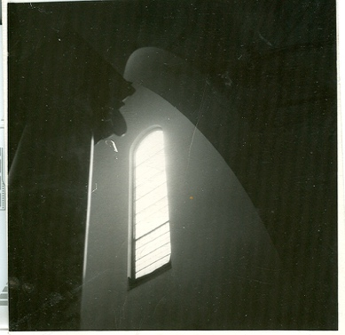

Reed says, “The paramount skill of the priest is to be aware of and sensitive to process whether consciously or unconsciously…. the power of the ritual to evoke symbols and discharge feelings, and be able to lead it so that the worshipers can be without distractions in worshiping God. … needs to appreciate the place of dependence in life and be able to work with people in the dependent condition.” Priests that are unable to accept that they are both human and symbols will fail at the task. And we need to acknowledge that no priest is perfect at the task. But there is a spectrum from competent to incompetent.

Back to the priest saying, “Put down the rosery beads.” Over generations people incorporated saying the rosary during mass into the extra-dependence part of their oscillation. Mass in Latin, lots of rhythm and gracefulness on movement, and saying the rosary. The church was now changing the way it wanted people to manage that oscillation. People had to develop a new competence. It took time. They were anxious. The priest was anxious too.
Reed takes note of the priest’s anxiety. Reed suggests that it is by the priest’s “conscious and deliberate investment” in the liturgical action that her own anxiety is managed and the liturgy becomes an authentic offering to God and the congregation. "The priest, when he conducts the liturgy, is in a perpetual tension because in order to manage (the extra-dependence activity) for the benefit of the worshipers, including himself, he has to maintain an intra-dependent activity.” Newly ordained priests often complain about their inability to worship in the way they could when in seminary or their old parish. Reed assumes that the new priest must have personal qualities including spirituality, needed skills and a capacity for leadership. "Otherwise, lacking these powers he may fall back on his position to assert himself." My take on this is that the new priest needs adequate skill in five areas: leadership ability, emotional maturity, spiritual maturity, competence in priestly skills (preaching, presiding, coaching people in prayer life), and priestliness (accepting that she is just human and is a symbolic person)
Reed continues, “because of this immense strain the priest needs to be clear about his boundaries, so that he knows exactly what to do and say, and be confident in what he represents. The development of set liturgies aids both these, by taking away the uncertainty about the content and diminishing anxiety” about the work activity.
It is in the use of ancient liturgies, shaped and authorized by the whole church, that the priest is strengthened in an identity as a representative of the truth and wisdom which is derived from the apostles. “The use of robes and vestments shows the distinctive role he is taking, and the architecture of the building and arrangement of furniture give clear signals about the significance of the successive phases of liturgy. During the service and after, the priest needs to be on alert to his own human reactions. If he tends toward overscrupulousness in concentrating on too many details which makes the ritual wooden or disjointed, he realizes that he is using the ceremony as a defense of himself against his anxieties and fears…. If he throws his prayer book away and behaves spontaneously, he may be experiencing the overruling of the Holy Spirit, or he may be succumbing to the seduction of the congregation’s regression to extra dependence which he is unable to control.” Which is to say—the priest steps out of role and gets lost.
In my story of a congregation feeling “jerked around” by a priest too given to his own feelings and instincts we might see the need for Reed’s insight that the development and use of set liturgies allows the priest to more effectively manage her anxiety which rise from her having to be “on”, to be at work. Being yourself and staying in role (accept being the symbol) is easier when you offer common prayer; worship owned by the larger and local church. Worship in which the words, rhythms and gestures are shared, belong to priest and people in a shared offering to God.
rag+

